Artificial intelligence
IGCSE Computer Science 0478 | 6.3 Artificial intelligence | Student booklet
Name: _______________________________ | Date: _____________

Start with robotics recall. Then explore the examples and explain how the systems work. Complete the understanding checks before turning to the exam practice. The worksheet and booklet have identical numbered tasks; use remaining questions as follow-up.
Task 1 Recall: robotics (6.2) [15 suggested marks]
Original retrieval practice. Closed book; choose (a), (b) and (d) if time is short.
(a) State three characteristics of a robot. [3]

(b) Complete the chain: a __________ detects distance; the __________ compares the reading with a threshold; an __________ moves or stops the mechanism. [3]

(c) Explain one benefit to workers and one drawback to the owner of robots lifting heavy boxes in a factory. [4]

(d) Explain how a distance sensor, microprocessor and motor make a delivery robot stop when a person is within 1 metre. [4]

(e) State what autonomous means for a robot. [1]

Explore From automation to intelligence
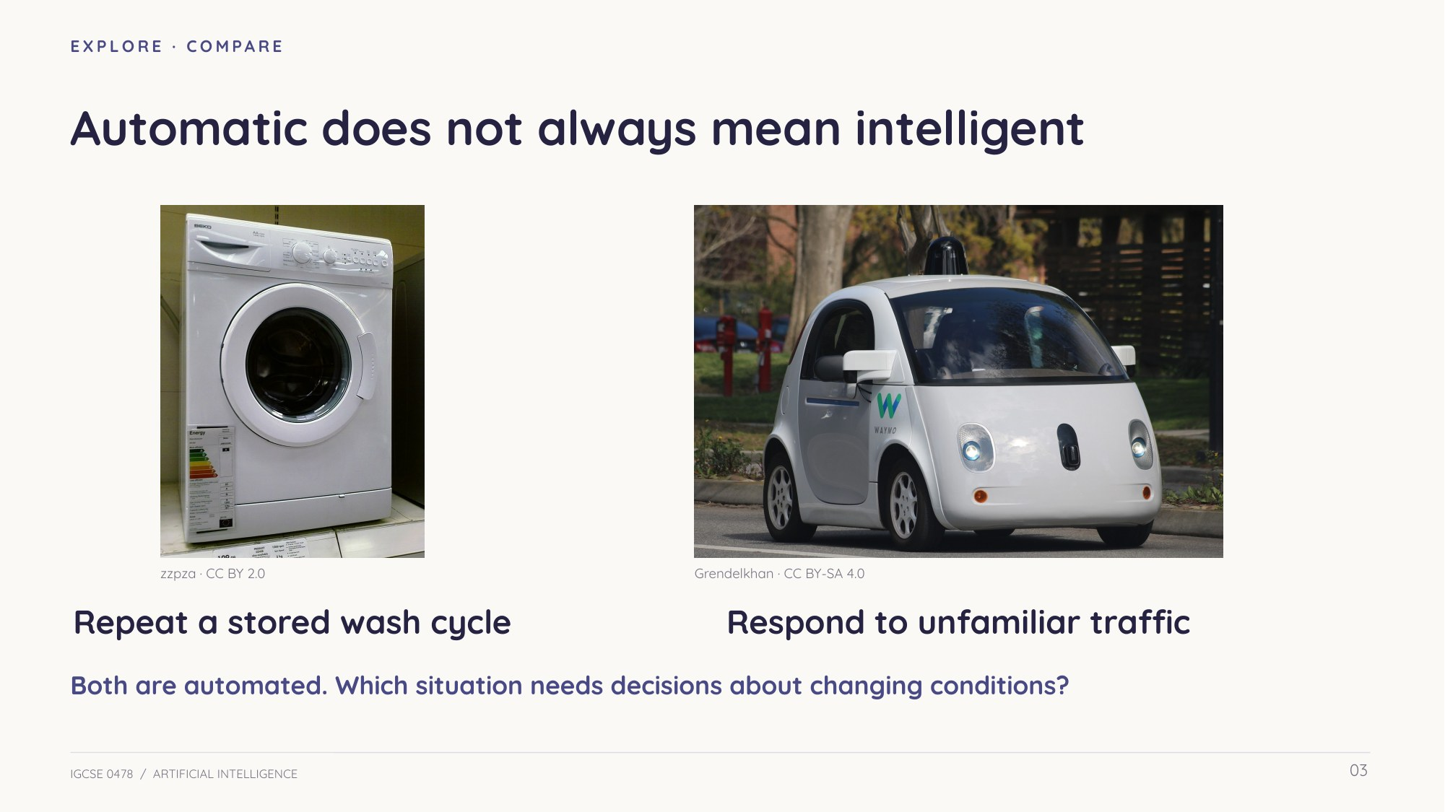
Slide 3 — Compare stored instructions with decisions in changing surroundings
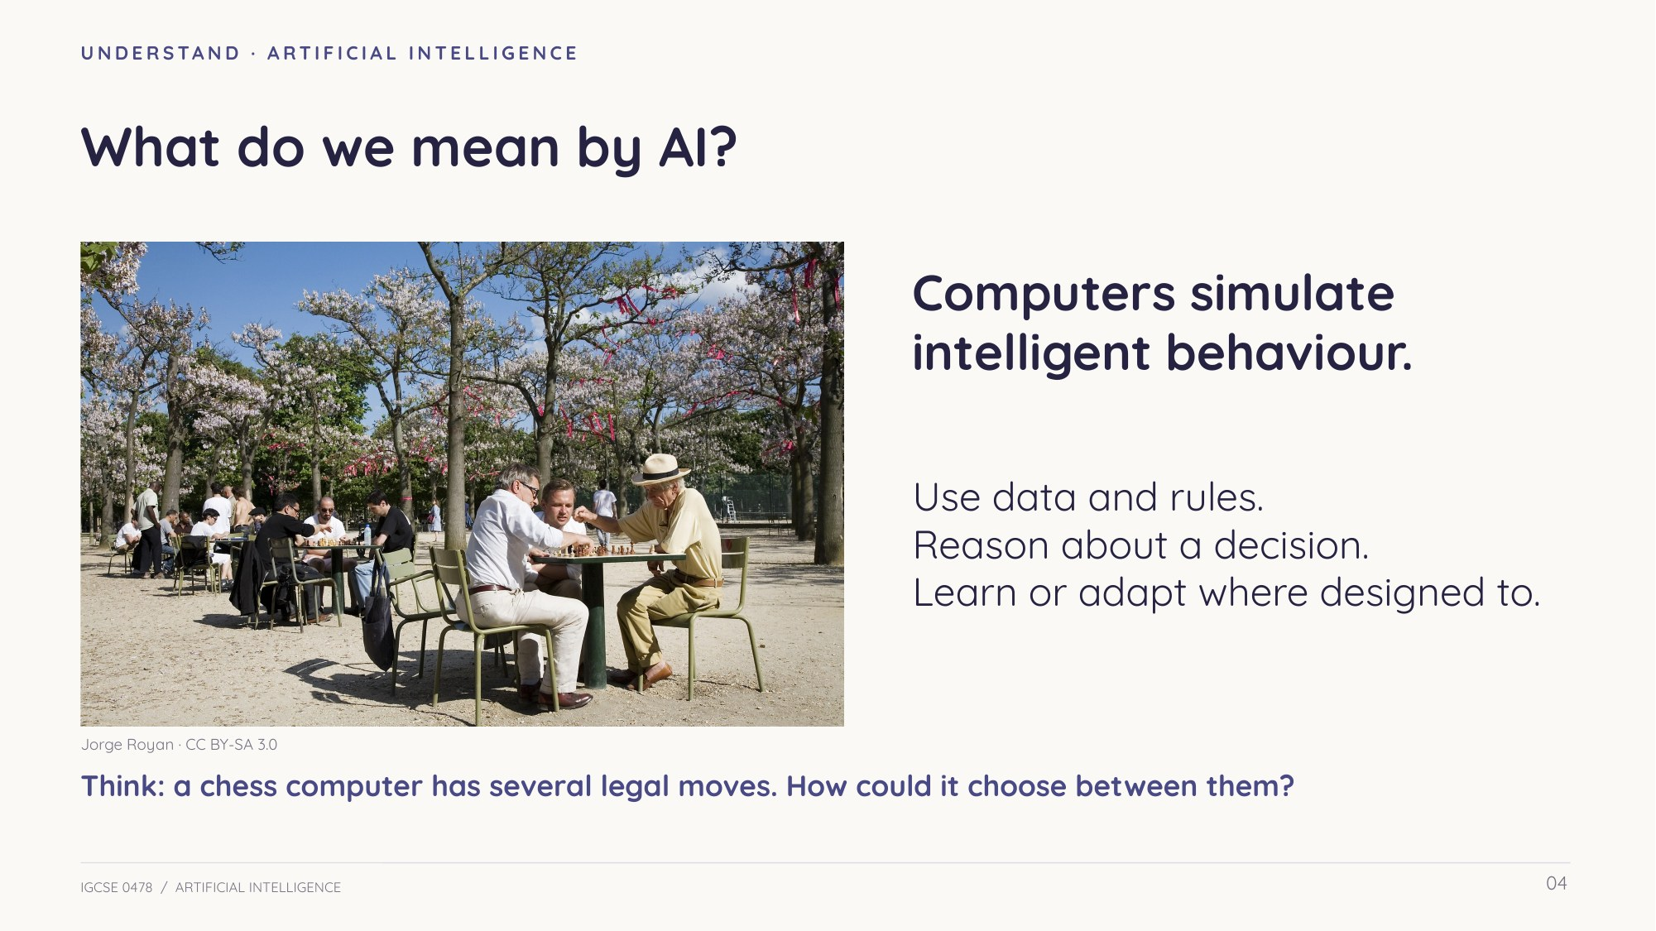
Slide 4 — Artificial intelligence: simulating intelligent behaviour
Understand An expert in a particular domain
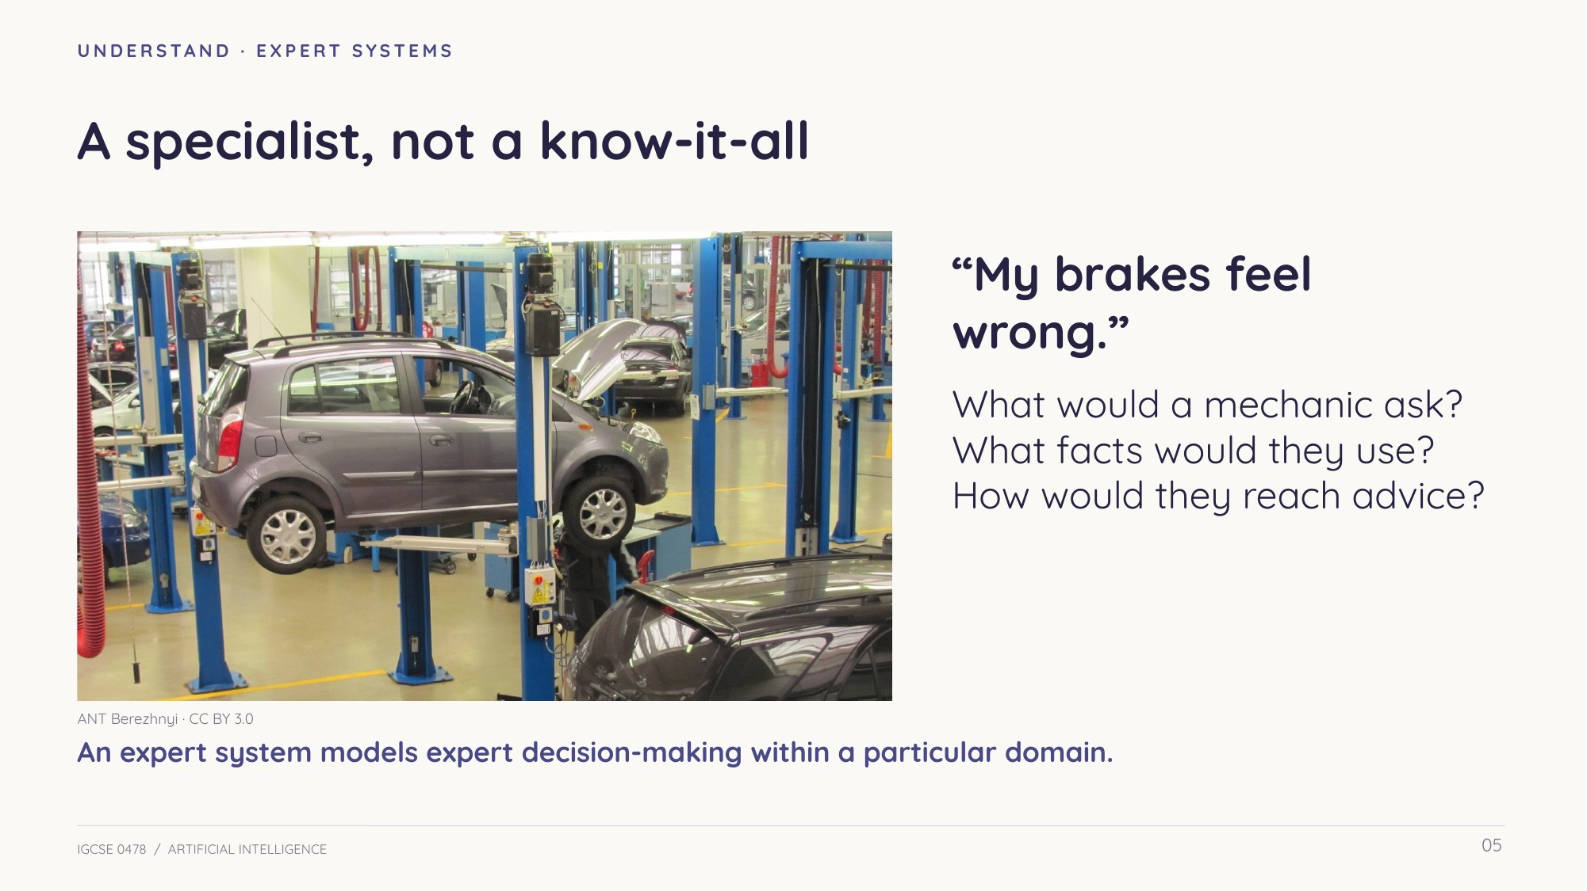
Slide 5 — A specialist adviser
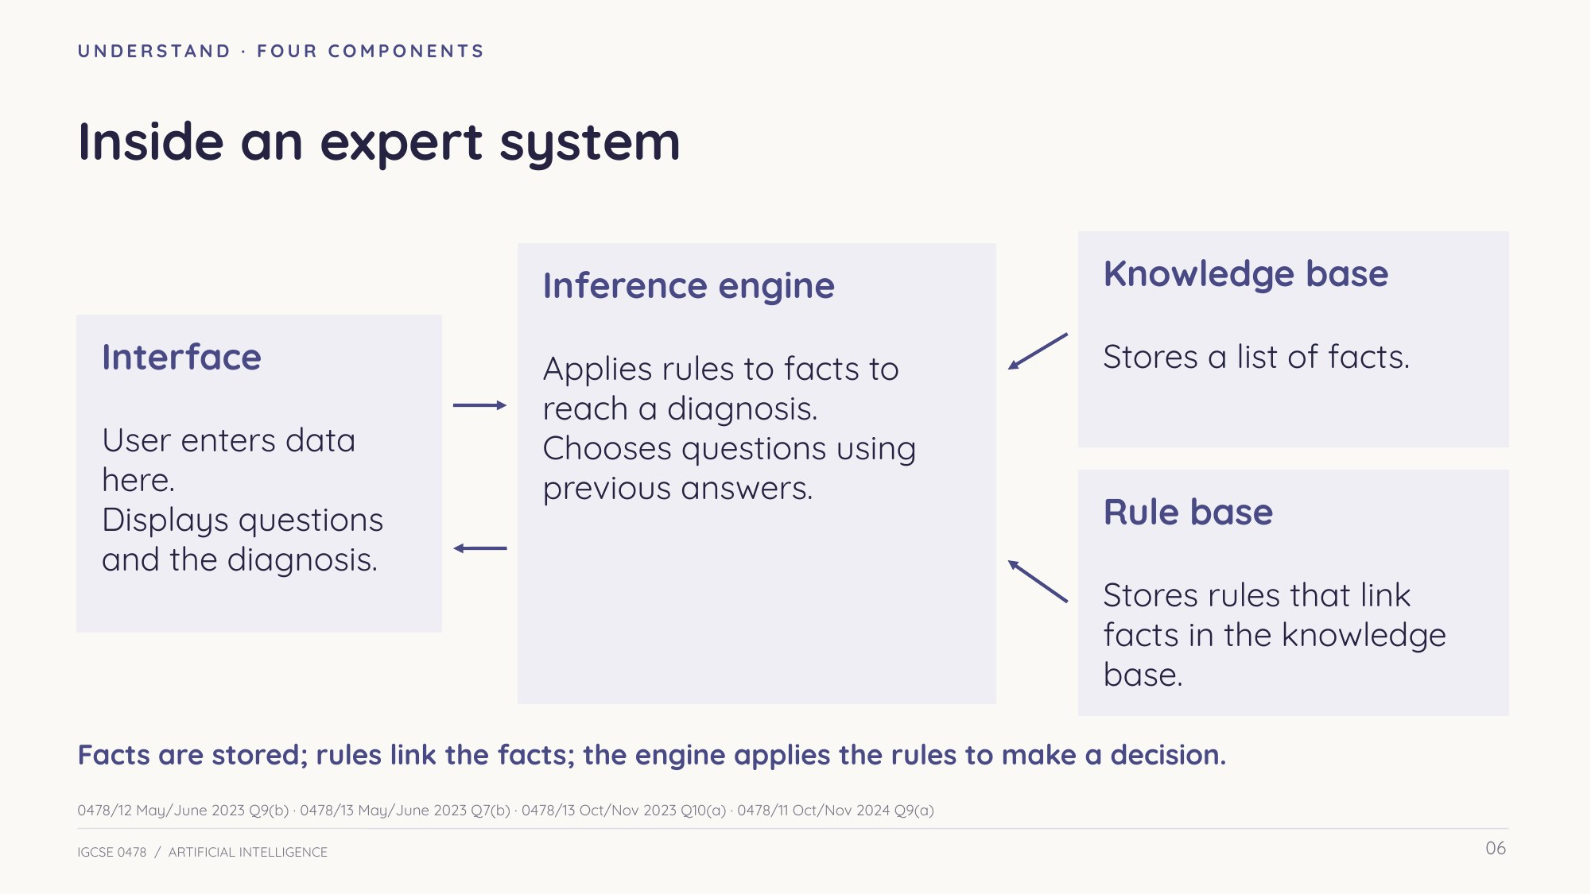
Slide 6 — The four components and how they connect
Understand Facts, rules and reasoning
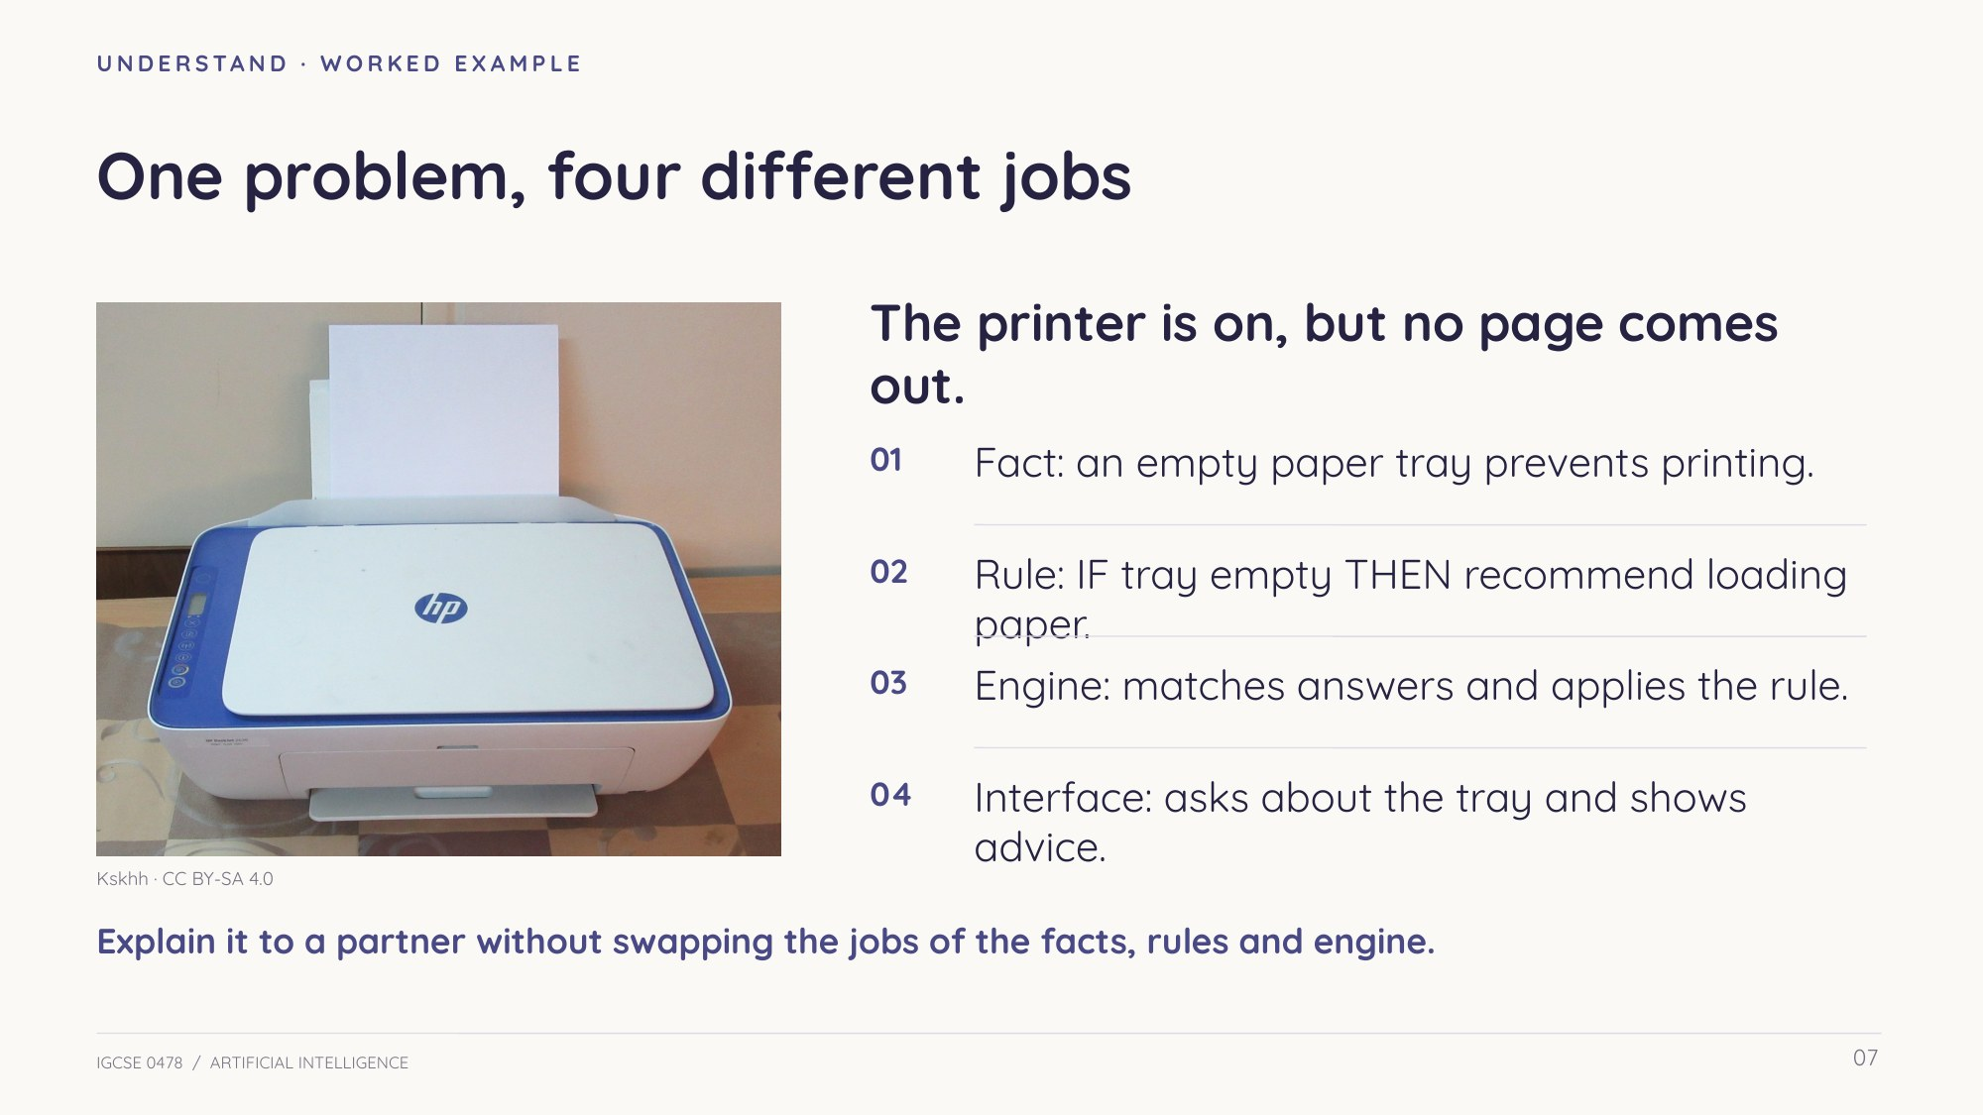
Slide 7 — Trace a different worked example: a printer fault
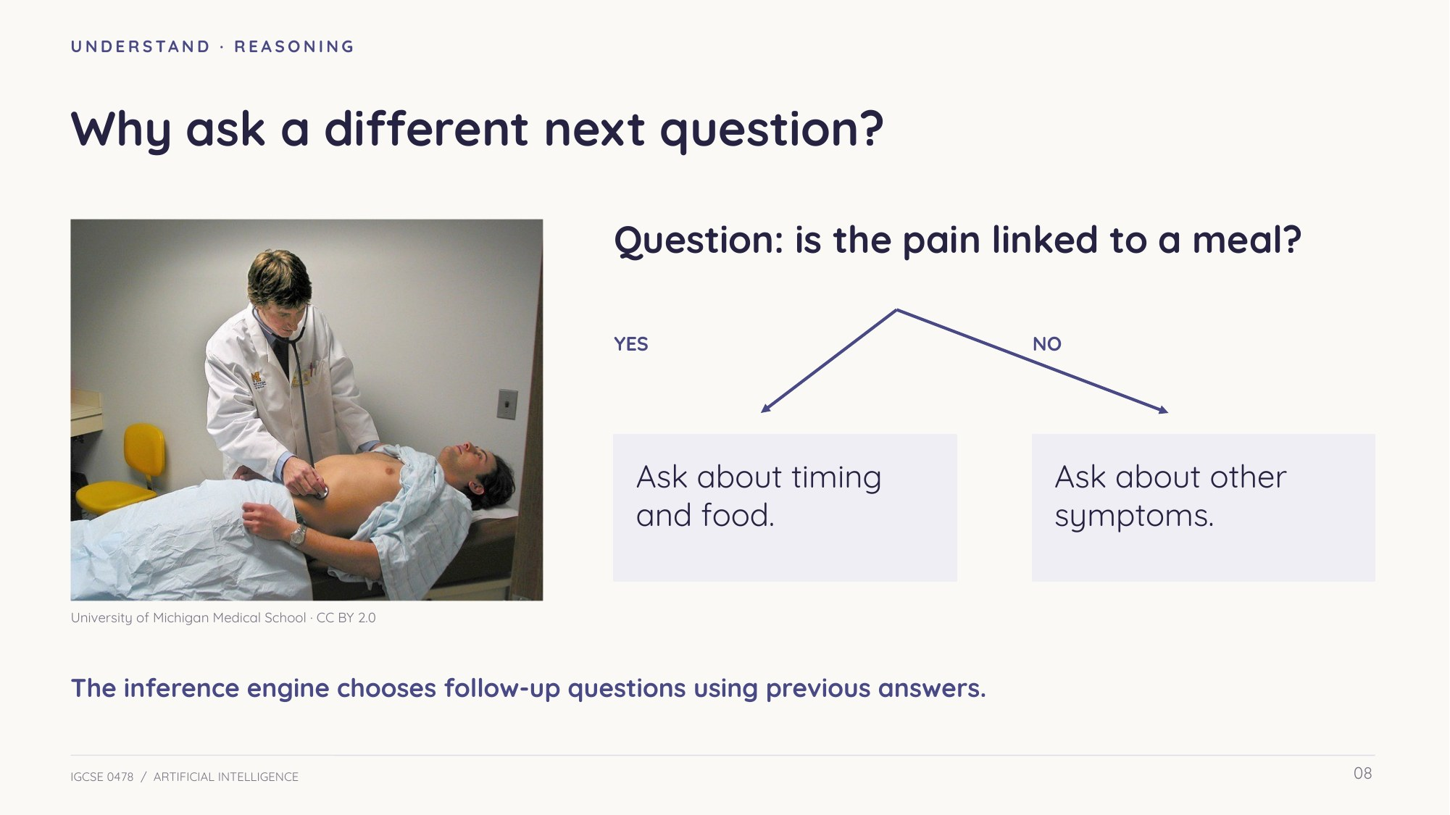
Slide 8 — Follow-up questions depend on previous answers
Apply Explain a diagnosis
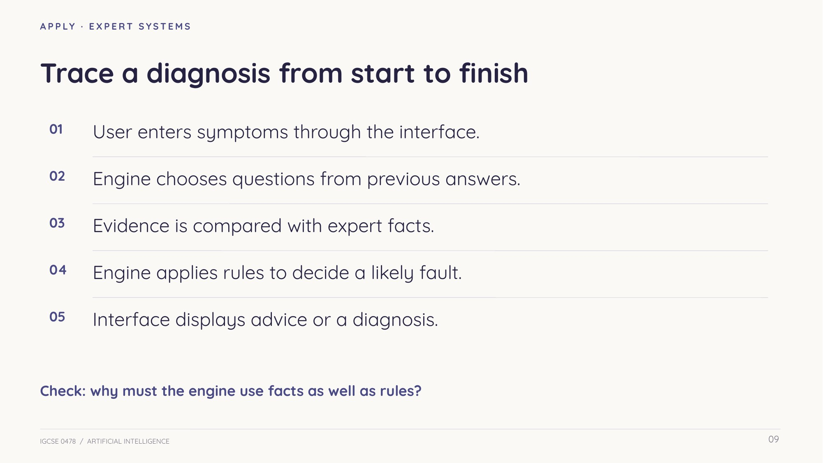
Slide 9 — From evidence to advice
In your own words: how do facts, rules and the engine work together? Why could a fixed-rule system work without learning?

Understand Learning from experience
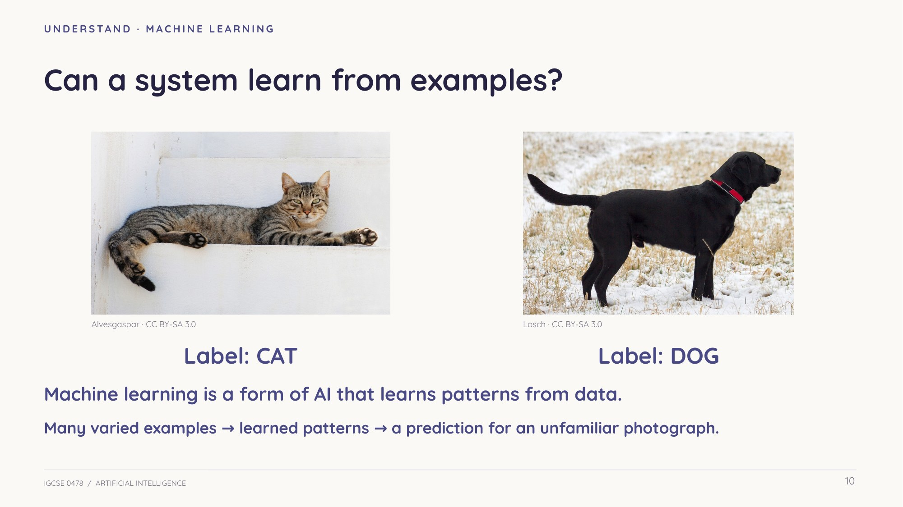
Slide 10 — Learned patterns from labelled examples
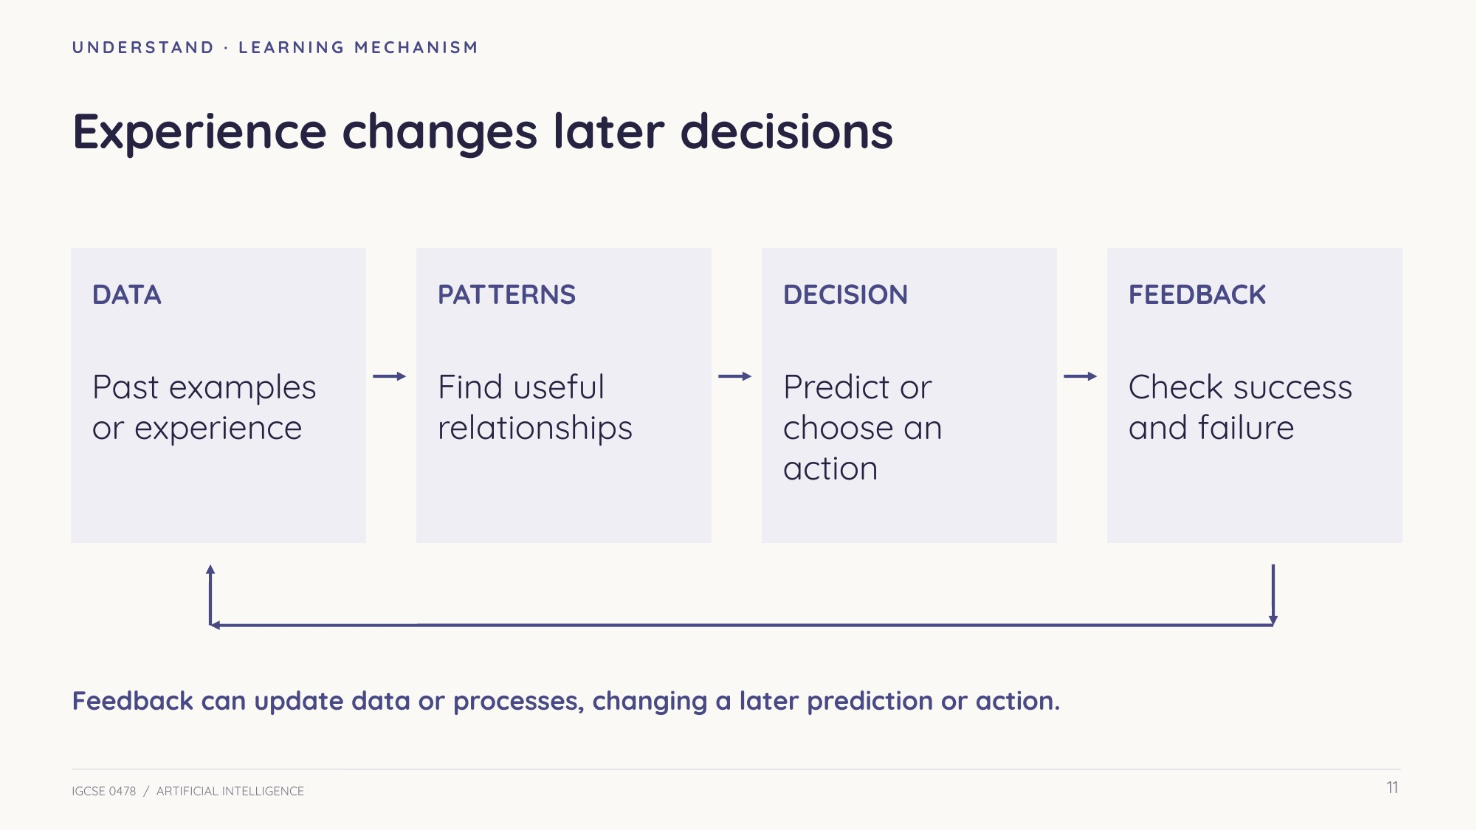
Slide 11 — Data, patterns, decisions and feedback
Understand Training and new situations
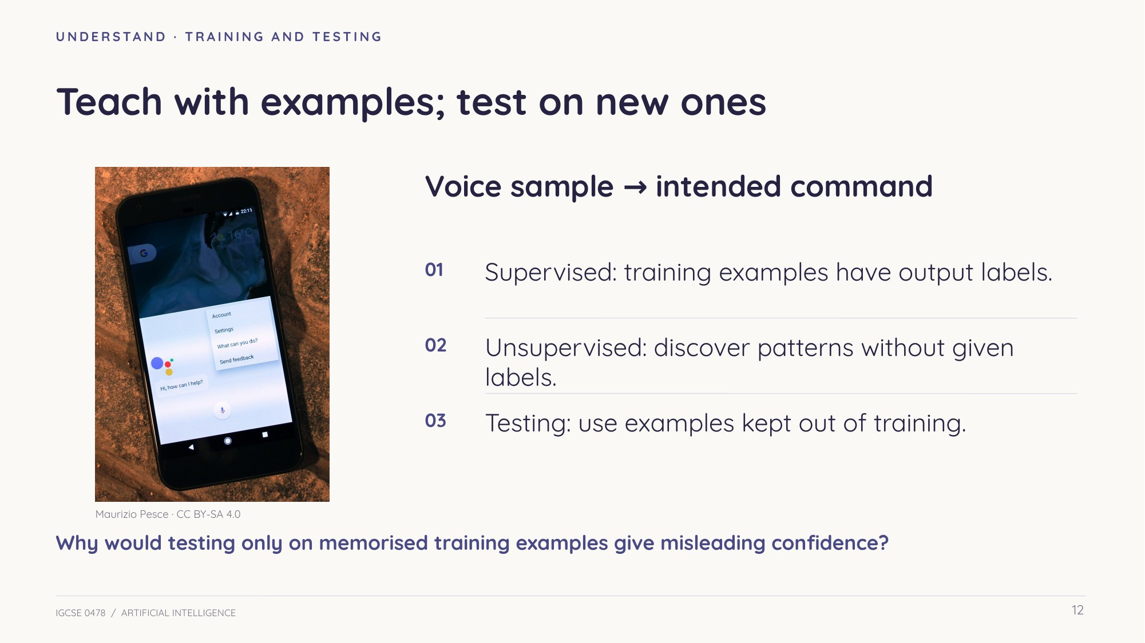
Slide 12 — Train on examples; test on new ones
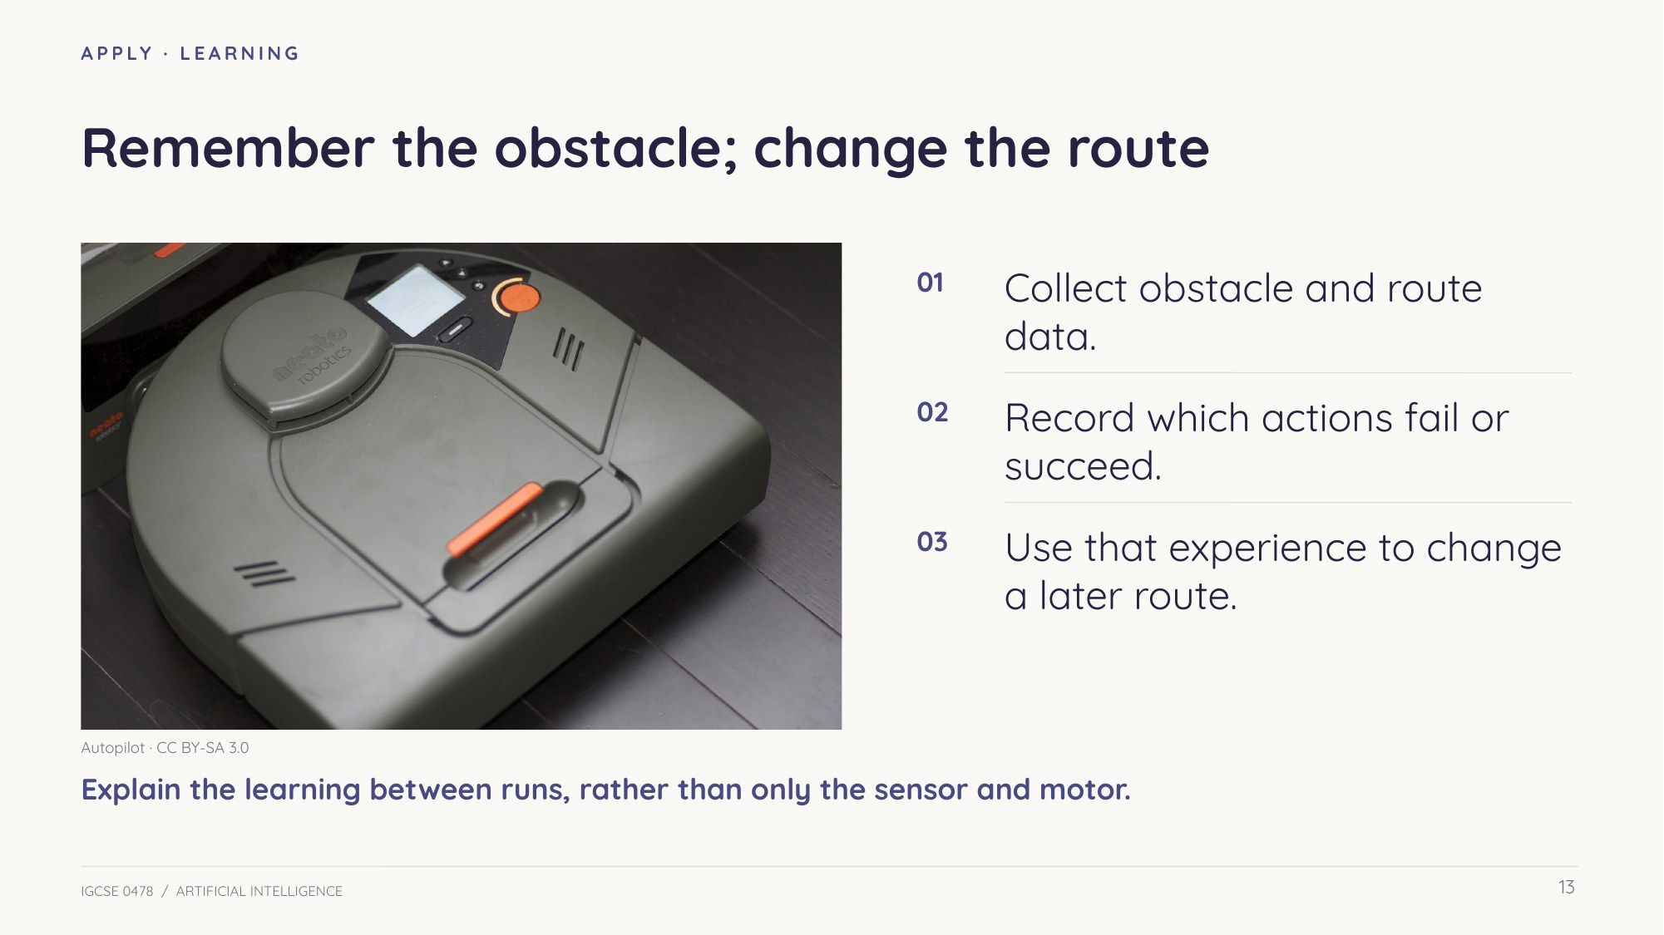
Slide 13 — Remember experience and change a later action
Check understanding Explain your choice
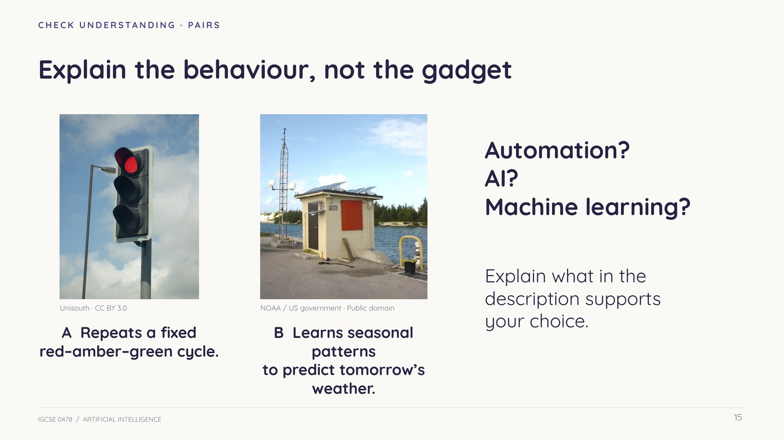
Slide 15 — The description matters more than the gadget
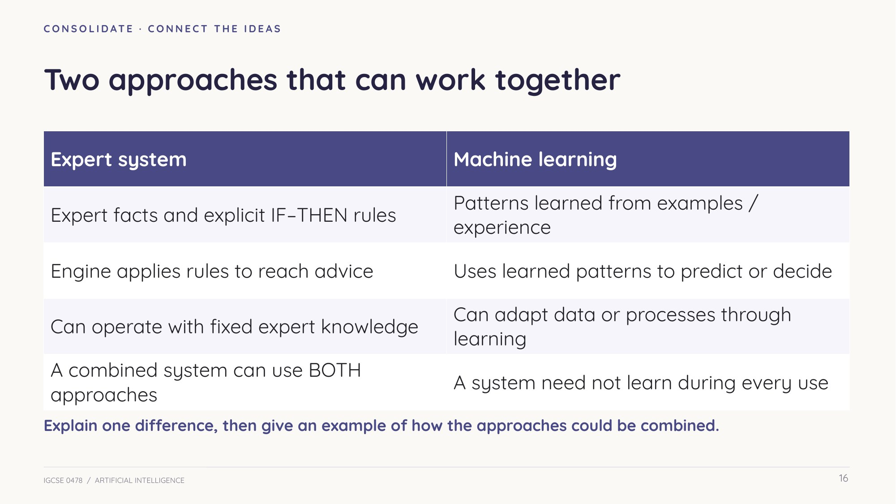
Slide 16 — Expert rules and machine learning can work together
Check understanding Before exam practice
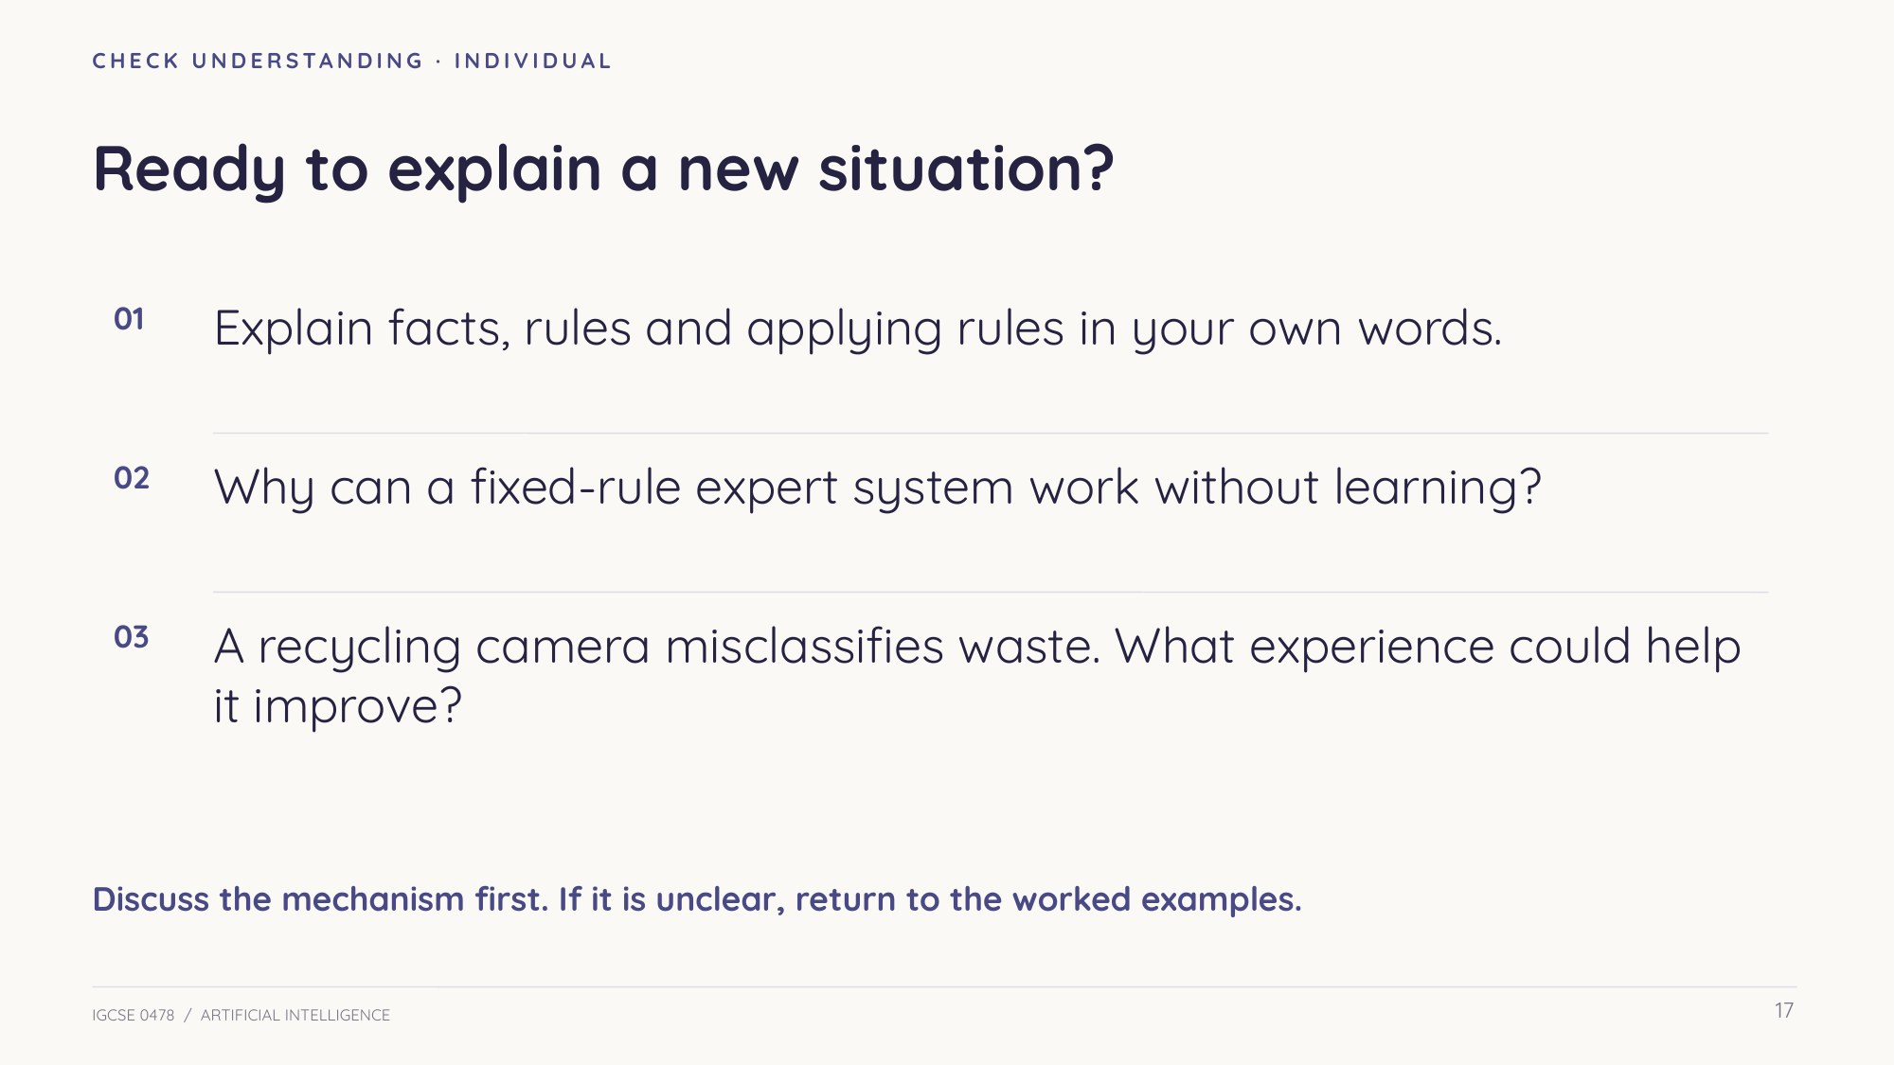
Slide 17 — Explain the mechanism in a new situation
A recycling camera misclassifies waste. What examples and feedback could improve its later classifications? Explain the change, rather than simply saying it gets better.

Practice Turn understanding into clear answers
Read the question carefully. Use the relevant component names, explain what happens and apply the mechanism to the given context. Feedback comes after an independent attempt. The model-answer slides are omitted from this student booklet.
Task 2 AI definitions and recognition [8 marks]
Questions are paraphrased from the cited past papers. Published Cambridge mark allocations retained.
(a) A game uses AI for its computer-controlled characters. Describe what is meant by artificial intelligence. [3]
0478/13 Oct/Nov 2025 Q6(a)

(b) A search engine has the ability to learn. Identify three OTHER AI characteristics. [3]
0478/12 Feb/Mar 2025 Q6(a)

(c) Machine learning belongs to which branch of computer science? [1]
0478/13 May/June 2025 Q6(f)(i)

(d) Robots can automatically adapt their own processes. Name this ability. [1]
0478/11 May/June 2025 Q8(e)

Task 3 Expert-system components and roles [17 marks]
Questions are paraphrased from the cited past papers. Published Cambridge mark allocations retained.
(a) An expert system already has an inference engine. Identify its three OTHER core components. [3]
0478/12 May/June 2023 Q9(a)

(b) Describe the role of the inference engine in an expert system. [2]
0478/12 May/June 2023 Q9(b)

(c) The rule base and inference engine are given. Name the other TWO core components. [2]
0478/13 May/June 2023 Q7(a)

(d) Describe the role of the rule base in an expert system. [2]
0478/13 May/June 2023 Q7(b)

(e) An expert system diagnoses faults in a robot vacuum. Select exactly THREE components from: knowledge base, operating system, firewall, server, printer, actuator, inference engine, rule base, encryption. [3]
0478/12 Oct/Nov 2024 Q8(b)

(f) Complete the expert-system paragraph using the word bank. Some terms are distractors. [5]
0478/13 Oct/Nov 2023 Q10(a)
Word bank: knowledge base, inference engine, rule base, interface, machine learning, mechanical engine, output device, question base.
An expert system stores its facts in A: __________________. B: __________________ applies C: __________________ to D: __________________ to reach a diagnosis. The user enters evidence through E: __________________.
Task 4 Explain a diagnosis [8 marks]
Questions are paraphrased from the cited past papers. Published Cambridge mark allocations retained.
(a) A car with faulty brakes arrives at a garage. Explain how its expert system operates to help diagnose the fault. [5]
0478/12 May/June 2024 Q10(b)

(b) A doctor has already entered symptoms through an interface. A diagnosis will be output. Describe how the expert system DECIDES that diagnosis. [3]
0478/12 May/June 2025 Q5(a)

Task 5 Machine learning and navigation [11 marks]
Questions are paraphrased from the cited past papers. Published Cambridge mark allocations retained.
(a) The garage’s expert system also has machine-learning capabilities. Describe what these capabilities mean. [4]
0478/13 Oct/Nov 2023 Q10(b)

(b) Explain how a robot vacuum cleaner can use machine learning. [3]
0478/12 Oct/Nov 2024 Q8(c)

(c) A robot must navigate puzzles containing paths, obstacles and dead ends. Explain how its program can use AI. [4]
0478/12 Feb/Mar 2023 Q6(d)(ii)

Follow-up Transfer the mechanism
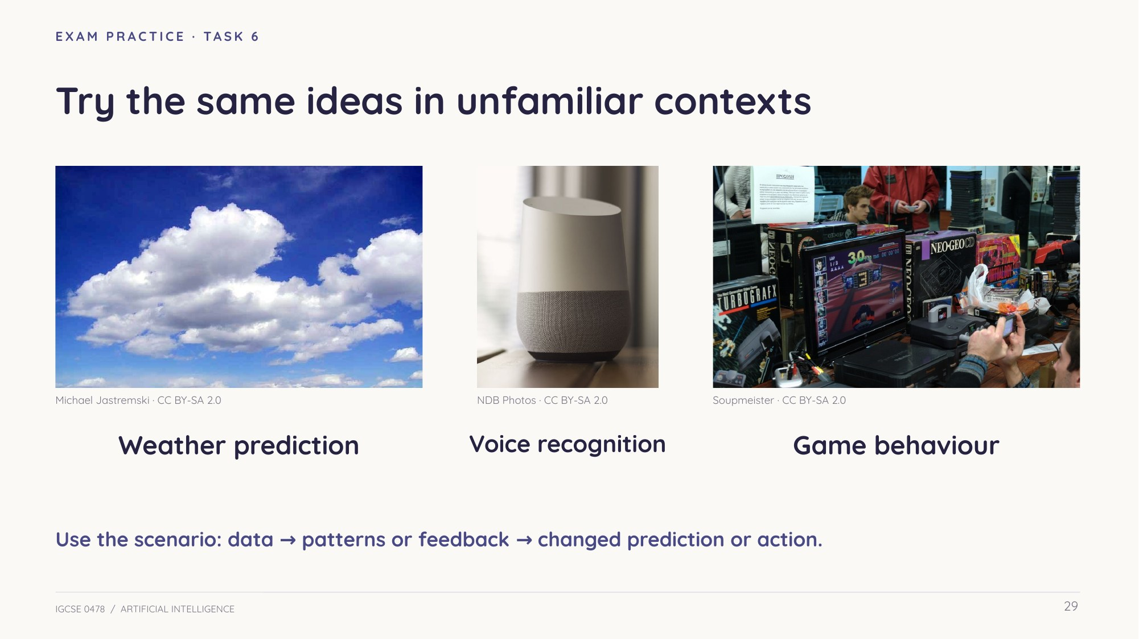
Slide 29 — New contexts: weather, voice and games
Attempt the five contexts independently. For each, identify relevant data, patterns or feedback, and a later change.
Task 6 Transfer bank: five real contexts [16 marks]
Follow-up / revision bank. Do independently before the worked-answer slides.
Questions are paraphrased from the cited past papers. Published Cambridge mark allocations retained.
(a) Explain how a search engine uses machine learning to improve the relevance of its results. [3]
0478/12 Feb/Mar 2025 Q6(b)

(b) Explain how a weather system can use machine learning to predict future weather. [3]
0478/13 May/June 2025 Q6(f)(ii)

Task 6 Transfer bank (continued)
(c) Explain how a smart speaker can use machine learning to improve voice-command input. [4]
0478/12 Oct/Nov 2025 Q7(c)

(d) Explain how AI can improve the movements and actions of computer-controlled game characters. [3]
0478/13 Oct/Nov 2025 Q6(b)

(e) Give THREE ways grocery-delivery robots could use AI. [3]
0478/11 Oct/Nov 2025 Q5(e)

Review Improve an explanation
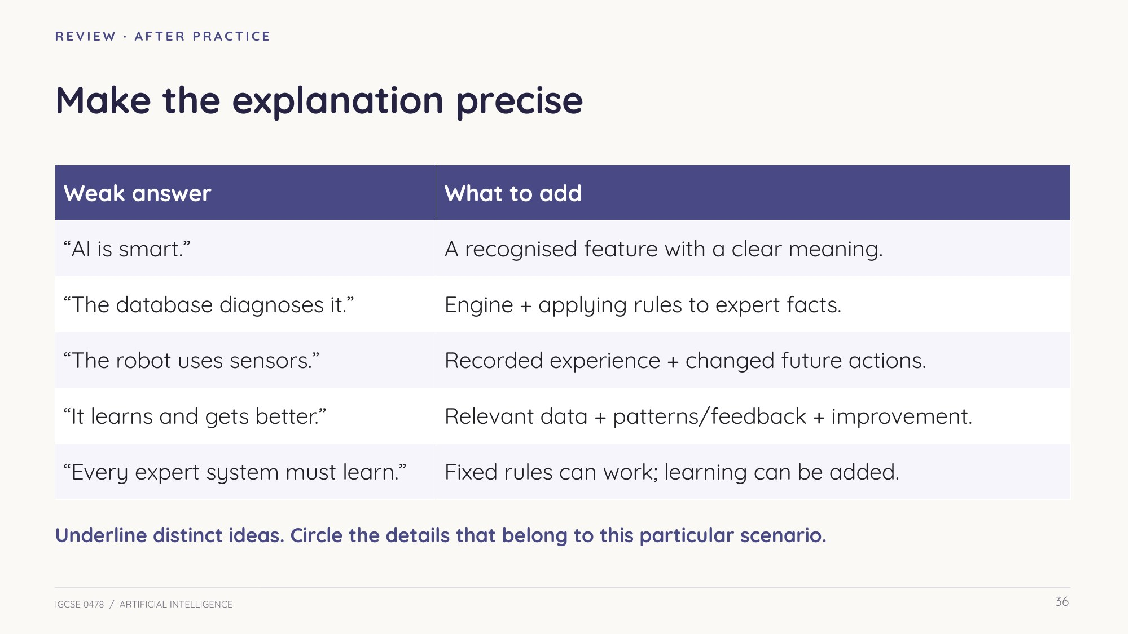
Slide 36 — Repair vague claims
Choose one of your answers. Underline distinct ideas. Circle the scenario details. Revise any sentence that only says it gets better.

Exit transfer
A recycling camera misclassifies waste. Explain how learning could improve later classifications.

Sources and photograph credits
Teacher research: 21 Paper 1 papers and their published Cambridge mark schemes (2023–2025); 29 AI parts audited. Practice questions are adapted/paraphrased from the cited papers; official mark allocations retained. Model answers and teaching commentary are our own.
Actual photographs from Wikimedia Commons. Images resized/recompressed with aspect-preserving crops in some slide placements; no subject alterations. Photographs illustrate representative hardware and settings.
FACTORY — Mixabest — CC BY-SA 3.0
Photograph source · Licence terms
VACUUM — Autopilot — CC BY-SA 3.0
Photograph source · Licence terms
SPEAKER — NDB Photos — CC BY-SA 2.0
Photograph source · Licence terms
WEATHER — NOAA / US government (photographer uncredited) — Public domain
Photograph source · Licence terms
GARAGE — ANT Berezhnyi — CC BY 3.0
Photograph source · Licence terms
DELIVERY — Q0ywo — CC BY-SA 4.0
Photograph source · Licence terms
CAR — Grendelkhan — CC BY-SA 4.0
Photograph source · Licence terms
WASHING — zzpza — CC BY 2.0
Photograph source · Licence terms
CHESS — Jorge Royan — CC BY-SA 3.0
Photograph source · Licence terms
PRINTER — Kskhh — CC BY-SA 4.0
Photograph source · Licence terms
DOCTOR — University of Michigan Medical School Information Services — CC BY 2.0
Photograph source · Licence terms
CAT — Alvesgaspar — CC BY-SA 3.0
Photograph source · Licence terms
DOG — Losch — CC BY-SA 3.0
Photograph source · Licence terms
ASSISTANT — Maurizio Pesce from Milan, Italia — CC BY-SA 4.0
Photograph source · Licence terms
CLOUDS — Michael Jastremski — CC BY-SA 2.0
Photograph source · Licence terms
GAMES — Soupmeister — CC BY-SA 2.0
Photograph source · Licence terms
TRAFFIC — Unisouth — CC BY 3.0
Photograph source · Licence terms
Complete exam audit: 0478 P1/Artificial Intelligence/AI_Exam_Coverage.md in the source repository.

